**Centripetal Force**

**Pre-lab questions**

1. What is the goal of this experiment? What physics and general science concepts does this activity demonstrate?
2. A 50-gram block has a weight of approximately 0.49 N on Earth. You send the block to the Moon. What changes: mass, weight, neither or both?
3. Should the inertial mass of an object be the same as the gravitational mass of the object?
4. Would our mass balance scale work equally well on the Moon as it does on the Earth? [The mass balance scale balances combinations of known masses against an unknown mass.]
5. How is the definition of matter related to inertial mass?

The goal of the experiment is to study rotational motion of a body travelling with constant speed in a circular path and to measure the centripetal force acting on the rotating body. You will measure directly the inertial mass mi as well as the gravitational mass mG of an object and compare them, thus putting the principle of equivalence to the test in the case of that object. You should find that the inertial mass is equal to the gravitational mass. The object under investigation is the black mass hanging down from a string in the centripetal motion apparatus (see figures 1 and 2 below).

**Equipment:**

* Centripetal force apparatus
* Mass hanger
* Slotted masses
* Mass balance
* Meter stick
* Stop watch (use computer)

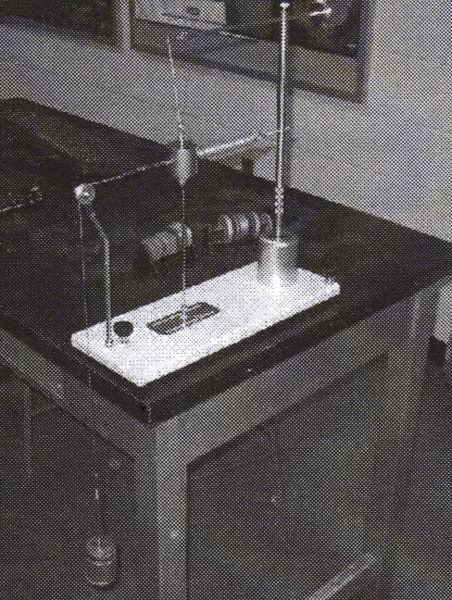

Figure 1: Photograph of the centripetal force apparatus with hanging masses attached to determine spring force.

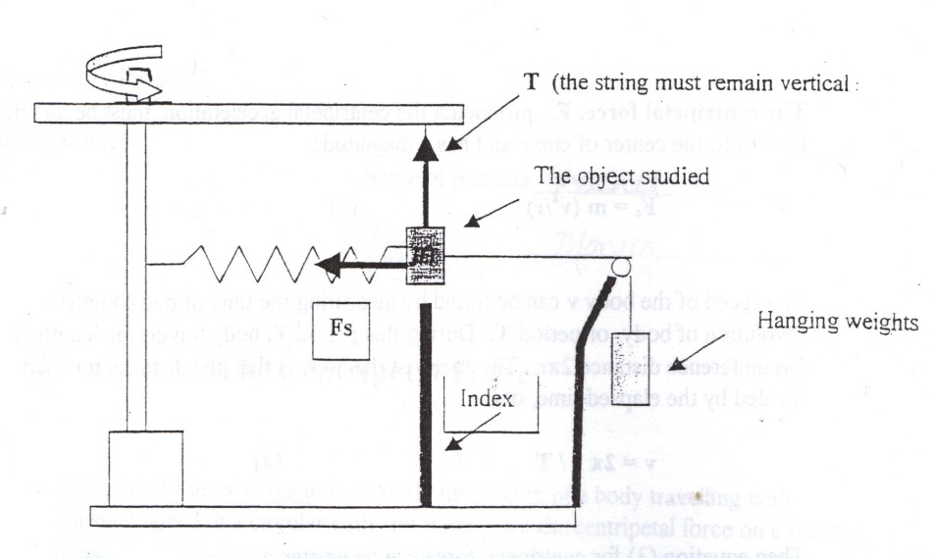

Figure 2: Schematic of the centripetal force apparatus with hanging masses attached to determine spring force.

The centripetal force apparatus consists of a mass ***m*** supported from a cross-arm attached to a vertical shaft. The shaft is supported in a metal housing containing bearings that permit the shaft to rotate freely. The cross-arm is counterbalanced to minimize vibration. An adjustably positioned vertical rod mounted on a base serves as a radius indicator. A pulley mounted on rod near one end of the base is used to facilitate the measuring of the force exerted by a spring with which the mass is coupled to the shaft.

**Introduction:**

When a body is in a uniform circular motion it is moving with constant speed in a circle of constant radius. Even though the speed of the body is constant, its instant velocity is constantly changing. This changing in direction of the velocity produces an acceleration that is always directed toward the center of the circle and is named a **centripetal acceleration.**

If the speed of body is $v$ and the radius of the circleis $r$, then the magnitude of centripetal acceleration is given by equation:

$a = v^{2}/r$ (1)

According to the Second Newton’s Law, acceleration is caused by a force:

$F = m a$ (2)

where m is a mass of the body.

**The centripetal force $F_{c }$**  that produces the centripetal acceleration, must be directed toward to the center of circle and has a magnitude:

$F_{c} = m \frac{v^{2}}{r}$ (3)

The speed of the body $v$ can be found by measuring the time of one complete revolution of body or a period $T$**.** During this period $T$**,** body travels the distance equals to the length of circumference $2π r$. So, the speed of the body is the distance traveled divided by the time elapsed:

$v = \frac{2π r}{T}$ (4)

Then equation (3) for centripetal force can be written as:

$F_{c} = m \frac{v^{2}}{r} = m \frac{4π^{2}r}{T^{2}}$ (5)

The principle of equivalence states that the ratio of gravitational mass to inertial mass is the same for all objects (whether it is a tiny particle here or a large cluster of galaxies at the “other side” of the Universe). We are so sure that this principle is correct for all the matter in the Universe that we have chosen a unique standard for both (its usual unit being the kilogram). In the framework of Newton, the principle of equivalence must be accepted as an incredible coincidence in Nature.

Recall that Newton found out that the acceleration of an object was proportional to the net force applied on the object (the force can be measured as the stretch of a standard spring for example) and the constant of proportionality characterizes a given object and determines how “hard” it is to get that object moving under a given force: F/a = m. For this reason, “m” is called the inertia, or inertial mass of the object. Matter is defined as anything whose inertial mass is non-zero.

The gravitational mass of an object is that quality of matter which generates a gravitational force between objects that possess it. All physicists are firmly convinced that all the matter in the universe has this quality. The gravitational mass mG of an object is of course the one that you use when you compute the weight (W = mGg) of an object (recall that the weight = the gravitational force due to the Earth acting on the object mG).

In this experiment, a body of a measured mass is rotated about a vertical axis in such a way as to produce a definite extension of a spiral spring. You will measure the centripetal force on a rotating body and will obtain it from equation (5) by measuring the mass ***m***, the radius of rotation ***r*** and the period of revolution ***T*.**

For period of revolution, you will measure the time for *N = 50* rotations and will find period as time elapsed ***t*** divided by number of rotations ***N***:

Period: $T = \frac{t}{N}$ (6)

The centripetal force is calculated using equation (5) and is compared with the gravitational force necessary to produce the same extension of the spring.

**Experiment**

* Align the equipment and measure the spring force.
* Attach one end of a piece of string to the mass and the other end to the mass hanger.
* Add mass to the hanger until the rotation mass is suspended perfectly vertical, as shown in Fig.1. (If the string is not vertical then the horizontal component of the tension in the string contributes as well to the centripetal acceleration and thus will falsify your results: It is thus very important that all measurements be made when the string is vertical!!)
* Adjust the position of the cross-arm and the extension of the eyebolt at the top of the mass to be rotated until the suspension is vertical and the extended spring is horizontal.
* Record the mass needed to stretch the spring to this position in table 1 provided below.
* The radius indicator rod should be in a position directly below the mass.
* Measure and record the radius of rotation, which is the horizontal distance from the center of the radius indicator rod to the center of the vertical shaft.
* Measure the period of motion for circular motion at the above radius of rotation.
  + Remove the string from the masses and practice rotating the shaft with your fingers. If apparatus tends to vibrate, move the counterbalance.
* With a little practice, the rotation rate can be adjusted to keep the body passing directly over the radius indicator rod. When you become proficient in keeping the rotation rate constant, measure the time needed to complete 50 rotations of the body.
* This is not a highly accurate experiment; therefore repeat the measurement at least three times.
  + Record the results of three trials in table 2 and find the average. Calculate the period T using average time: T = t/50
* Measure a range of possible spring forces.
  + Since the mass probably strayed somewhat inward and outward of the radius indicator during the timing of the rotation in step 2, the pulling force Fs that the spring exerted on the mass during that time varied somewhat (because of the varying stretch of the spring). To find the range of Fs, find the range of hanging weights (from Mmin to Mmax ) that reproduces the amount by which you observed the mass straying in step 2. Record this in table 1.
* Remove the rotating body from the apparatus and measure its gravitational mass using the mass balance. Record this mass.

**Data:**

Table 1: Mass required to stretch spring and spring force providing centripetal acceleration.

|  |  |  |
| --- | --- | --- |
| **Mass required to stretch spring** | **Mass [kg]** | **Spring Force [N]** |
| **mideal**  directly above indicator rod |  |  |
| **mmin**  just short of indicator rod |  |  |
| **mmax**  just beyond indicator rod |  |  |

**Gravitational mass: mG = _____________________________________________________**

Table 2: Radius of revolution and time measurements.

|  |  |  |  |
| --- | --- | --- | --- |
| **Trial** | **Radius [m]** | **Time for 50 revs *t* [s]** | **Period for 1 rev *T* [s]** |
| **1** |  |  |  |
| **2** |  |  |  |
| **3** |  |  |  |
| **Averages:** |  |  |  |

**Computations and Analysis:**

We can calculate the ideal spring force, and a range for the spring force. From the schematic in figure 2, you could write an equation for the ideal spring force:

$$F_{s-ideal}=m_{ideal}*g$$

The equations for the minimum or maximum observed spring forces are similar. Record these values in table 1.

(To have the forces in Newtons, do not forget to convert units in SI : meter, kg, sec.)

Data in table 2 allow us to calculate centripetal acceleration using equations (1) and (4) from the introduction:

$a=\frac{4π^{2}r}{T^{2}}=$

**_______________________________**

By realizing that the centripetal force was supplied by the spring. We can set $F_{c}=F_{s}$, and use equation (5) to find the mass from our inertial data:

$$m_{i}=\frac{F_{s}}{a}$$

Because we have an ideal spring force (if the mass was perfectly above the indicator rod), we can find

$m_{i-ideal}$:_________________________________

We can also calculate a range of possible masses from the minimum and maximum spring force (a range should be reported as two numbers)

$m_{i-min}$ to $m_{i-max}$: ____________________________________________

Compare this inertial mass to the gravitational mass measured with a balance by computing a percent difference using:

$$\frac{\left|m_{inertial}-m_{G}\right|}{m_{G}}×100\%=$$

**Conclusions:**

1. What is the centripetal force? How can we measure it?
2. How does radius of rotation affect the period of rotation and centripetal force?

**Sources of errors:**

What assumptions were made that caused error? What is the uncertainty in your final calculation due to measurement limitations?